REPORT

|  |  |
| --- | --- |
| Date | 10 November 2022 |
| Team ID | PNT2022TMID11633 |
| Project name | Analytics for Hospital Health Data |
| Team members | Dharani Kumar C  Keerthivasan B  Akil V  Mohammed Upayathulla M |

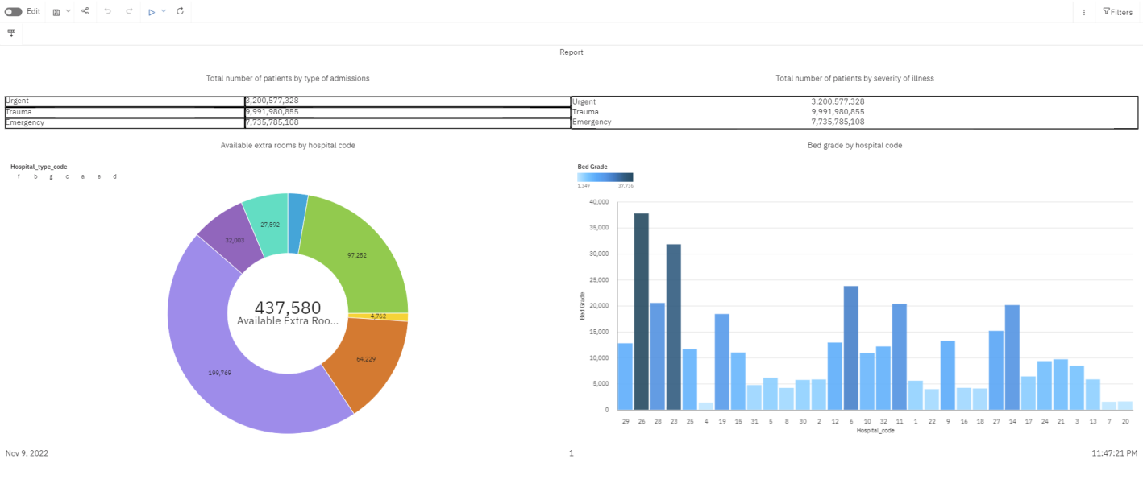

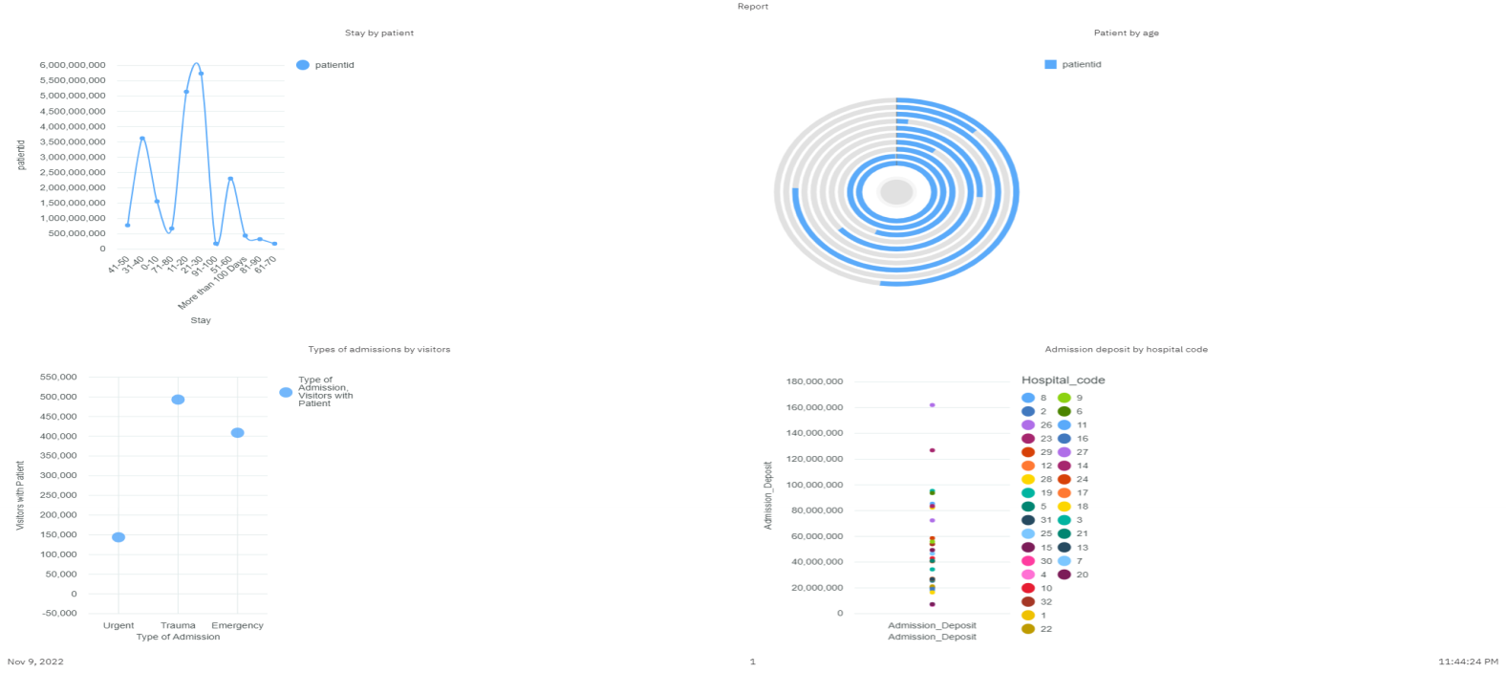

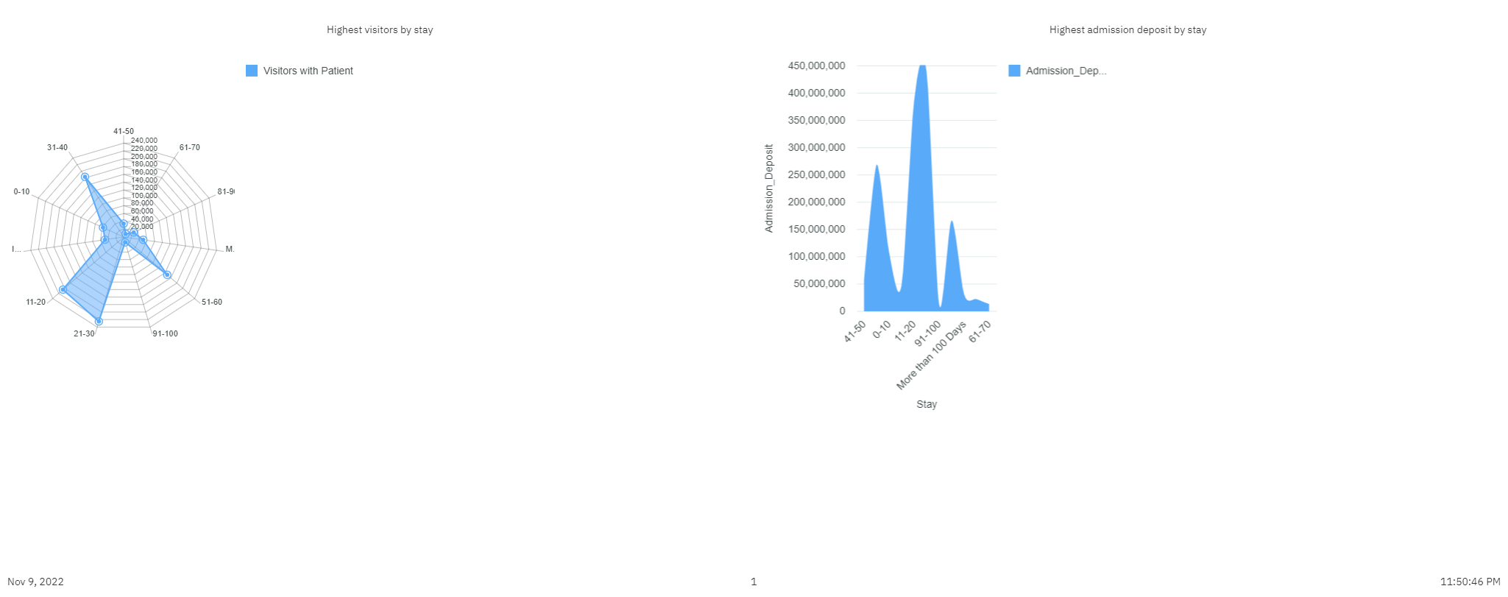

Reference link:

[https://us3.ca.analytics.ibm.com/bi/?perspective=authoring&id=i5B447066C21345EB8F03F569AB388CD7&objRef=i5B447066C21345EB8F03F569AB388CD7&action=run&format=HTML&cmPropStr=%7B%22id%22%3A%22i5B447066C21345EB8F03F569AB388CD7%22%2C%22type%22%3A%22reportView%22%2C%22defaultName%22%3A%22Report%20view%20of%20Report-3%22%2C%22permissions%22%3A%5B%22execute%22%2C%22read%22%2C%22setPolicy%22%2C%22traverse%22%2C%22write%22%5D%7D](https://us3.ca.analytics.ibm.com/bi/?perspective=authoring&id=i5B447066C21345EB8F03F569AB388CD7&objRef=i5B447066C21345EB8F03F569AB388CD7&action=run&format=HTML&cmPropStr={"id"%3A"i5B447066C21345EB8F03F569AB388CD7"%2C"type"%3A"reportView"%2C"defaultName"%3A"Report view of Report-3"%2C"permissions"%3A%5B"execute"%2C"read"%2C"setPolicy"%2C"traverse"%2C"write"%5D})